MINOT PREDATOR HUNT
25 OCTOBER 2008

Coyotehunter.net will be holding a 1- day coyote hunting tournament in Minot, ND 25 October, 2008. Check-in starts at 5:00 AM at Ambush Kennels. We will go over the rules at that time. The afternoon check-in will be at 8:00 PM at the Ambush Kennels. This hunting tournament is a one-day contest, $40 per team (90% payback). 1st 30%, 2nd 25%, 3rd 20%, 4th 15%, & 5th 10% place finishes will be awarded to the teams with the highest 1-day total. Entry will be limited to 35 teams. Cash will be awarded for the largest and smallest coyotes (100% pay back). All rules will be strongly enforced.

Go to www.coyotehunter.net for information on other upcoming tournaments, rules, and accommodations. For information, rules and entry form, contact:
Levi McNally 218-329-9142 Chris Lyon 320-492-8953 Terry Bush 701 833 5575

Name_________________________________________
Address_______________________________________ City/State/Zip___________________________________

Phone_________________________________________
E-mail________________________________________

Name_________________________________________
Address_______________________________________ City/State/Zip___________________________________

Phone_________________________________________
E-mail________________________________________

$40 Tournament Y/N
$10 Smallest Y/N
$10 Largest Y/N

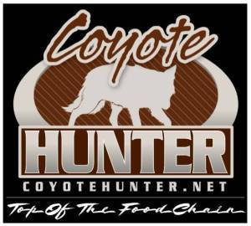

Mail completed registrations to:
Coyotehunter.net
PO Box 1538
Douglas, Wy 82633

