Luke Oyloe Memorial Hunt
17 OCTOBER 2009

Coyotehunter.net will be holding a 1- day coyote hunting tournament in Minot, ND 17 October, 2009. Check-in starts at 5:00 AM at Ambush Kennels. We will go over the rules at that time. The afternoon check-in will be at 8:00 PM at the Ambush Kennels. This hunting tournament is a one-day contest, $40 per team (90% payback). 1st 30%, 2nd 25%, 3rd 20%, 4th 15%, & 5th 10% place finishes will be awarded to the teams with the highest 1-day total. A scholarship in Luke’s name has been set up at the Williston school that Luke attended. See rules for details. Entry will be limited to 50 teams. Cash will be awarded for the largest and smallest coyotes (100% pay back). All rules will be strongly enforced. Go to www.coyotehunter.net for information on other upcoming tournaments, rules, and accommodations. For information, rules and entry form, contact: Levi McNally 218-329-9142 Chris Lyon 320-492-8953

Name_________________________________________
Address_______________________________________ City/State/Zip___________________________________

Phone_________________________________________
E-mail________________________________________

Name_________________________________________
Address_______________________________________ City/State/Zip___________________________________

Phone_________________________________________
E-mail________________________________________

$40 Tournament Y/N
$10 Smallest Y/N
$10 Largest Y/N

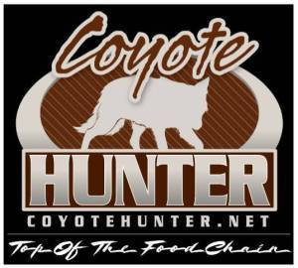

Mail completed registrations to:
Send entry forms to:

Coyotehunter.net
715 N 5th ST
Douglas, Wy 82633

