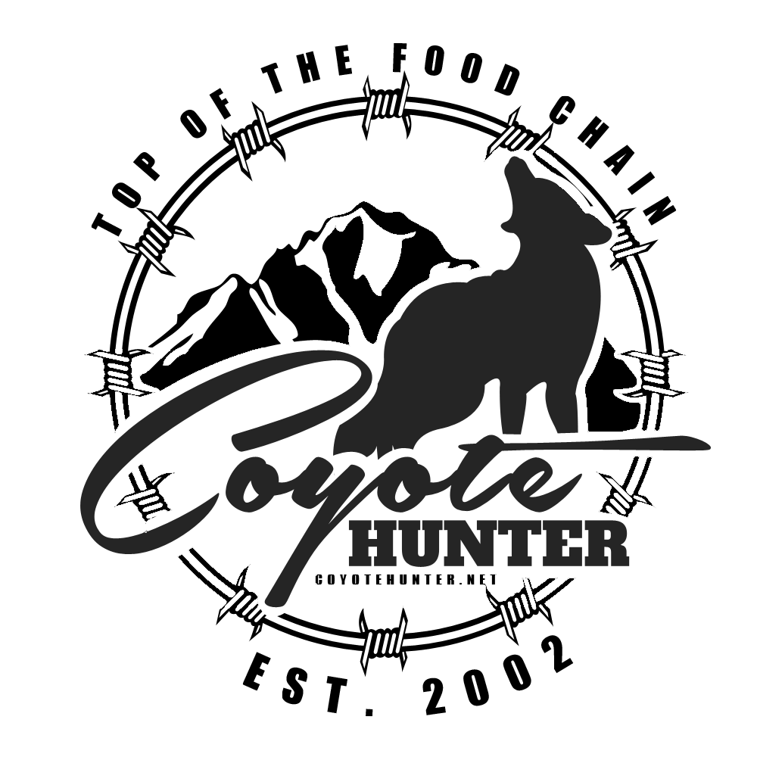

**15th ANNUAL**

**NORTH DAKOTA COYOTE CLASSIC**

**DICKINSON, ND • JANUARY 6-7, 2017**

**15th Annual North Dakota Coyote Classic • Dickinson, ND • January 6-7, 2017**

**Name Name**

**Address Address**

**Phone Phone**

**Email Email**

**Coyotehunter.net is proud to host a two-day coyote hunting tournament at the Motel 6 in**

**Dickinson, North Dakota January 6 – 7, 2017**

**Entry fees are just $300 per team. Pro Division: You can register your team in the Pro Division for an additional $150 or Amateur Division for an additional $50.**

**100% payback**

**Cash, plaques and prizes will be awarded to the teams with the highest two-day total. Payback will be as follows:**

**1st 30%, 2nd 25%, 3rd 20%, 4th 15%, 5th 10%**

**Cash will be awarded to the teams for the largest and smallest coyotes and will be paid out each night. 100% payback**

**All rules will be strictly enforced. At least one member of each team should be in attendance at the rules meeting January 5th at 7:00 pm. More than $20,000 dollars in cash and prizes was awarded at last year’s event.**

**Visit www.coyotehunter.net to register at the on-line store. For information on accommodations and rules, email us at** [**info@coyotehunter.net**](mailto:info@coyotehunter.net)**.**

**Please complete the form and remit to: CoyoteHunter.net, P.O. Box 892, Douglas, WY 82633**

**$300 Entry Fee Y / N**

**Additional: 100% payback**

**$150 Pro Y / N**

**$50 Amateur Y / N**

**$15 Largest Y / N**

**$15 Smallest Y / N**

**Entry Date**